🟦 SATURDAY — Upper Body + Core
1 | Incline Dumbbell Press  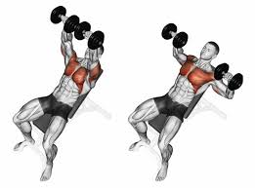
2 | Pull-Ups · (or Lat Pulldown)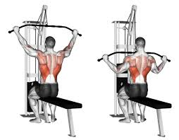
3 | Seated Dumbbell Shoulder Press · 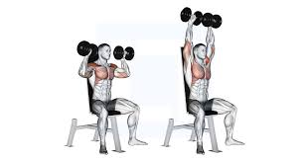
4 | Single-Arm Dumbbell Row ·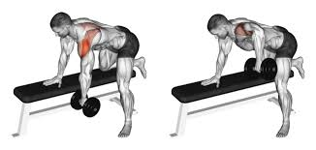
5 | Lateral Raises ·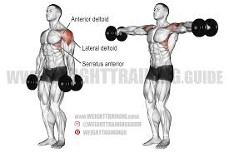
6 | Incline Dumbbell Curls ·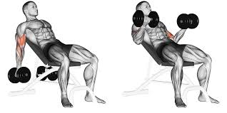
7 | Rope Tricep Pushdowns ·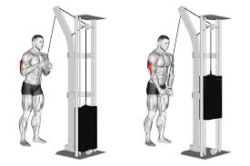
8 | Hanging Leg Raises ·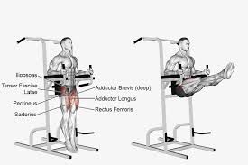
9 | Cable Crunches ·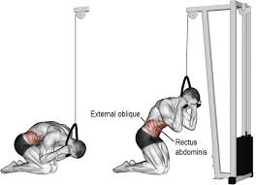
10 | Plank ·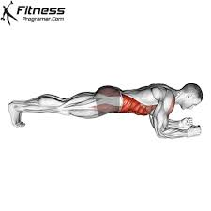

🟩 WEDNESDAY — Lower Body + Core + Conditioning

1 | Goblet Squats ·  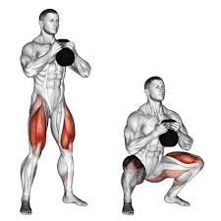
2 | Romanian Deadlifts · 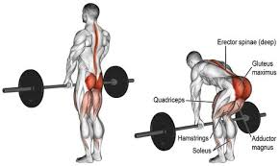
3 | Walking Lunges · 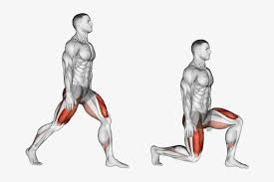
4 | Bulgarian Split Squats ·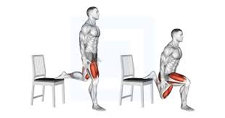
5 | Standing Calf Raises ·  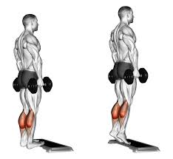
6 | Bicycle Crunches ·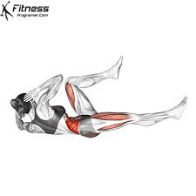
7 | Russian Twists ·  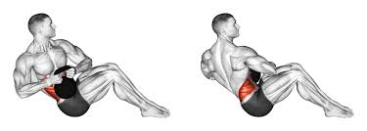
8 | Mountain Climbers ·  